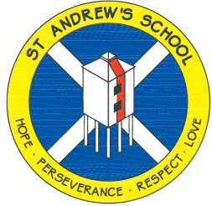
St Andrew’s Church of England Junior School

Helping
Your Child
With Spelling
September 2018

Spellings at St Andrew’s: A Parent Guide
As the children settle in to a new academic year, we thought now would be a good opportunity to recap and clarify how spelling is taught in line with current curriculum guidelines. For parents of children in Year 4, 5 and 6, you may notice some small changes.
How will spelling in the ‘new curriculum’ work on a weekly basis?
Your child will be receiving spellings to learn on a weekly basis. Historically, these spellings have been sent home for children to practise, which has included writing the spelling in a sentence. Research shows, and we can confirm, that this ‘method’ is not highly effective when learning and embedding spellings. Our aim is for the children to gain a deeper understanding of their spellings, rather than just learning them for the short term, verbatim, for a test.
This year, there will be a much heavier emphasis on learning the weekly spellings in class:
- On a Friday, there is a taught spelling session with the whole class
- During the following week, children will have the opportunity to discuss their meanings daily with their teacher and have the opportunity to complete an ‘in-class’ task . There will also be a strong focus on patterns within the words such as any prefixes, suffixes and letter combinations as well as discussing the word group; e.g, noun, adjective etc…
As part of the curriculum’s strategy, children are encouraged to split words into parts and we will be using terminology such as ‘syllables’, ‘phonemes’ and ‘graphemes’, ‘synonyms’ and ‘antonyms’ (a guide to these terms is included with this letter).
How can I help my child with spellings at home?
The weekly spellings will be available for you to see on the school’s website, on the class pages. We would still expect children to practise these spellings regularly at home (children will still be tested on their spellings each Friday). Here are some ideas of things you can do to help your child:
- While discussing these spellings, think about any patterns, prefixes or similar words that you know as these might help to build links (e.g, words containing tri- at the beginning will share a reference to three and it will be really helpful if children made these connections in their learning).
- Identify the ‘root ’word in a longer word e.g. musician (music), vicious (vice).
- Talk about word meanings and encourage your children to ask if they are not sure and discuss whether words are nouns, verbs, adjectives etc. Evidence has shown that children who read widely and have an interest in words have a deeper understanding of word meanings and spellings.
- For unfamiliar words, rather than tell the children what it is, encourage them to segment the word into manageable chunks – either ‘syllables’ or ‘graphemes’. (See glossary)
- Games help, too. Wordsearches and crosswords, anagrams as well as traditional games like Scrabble.
- Having access to a dictionary (which can include ‘online’ dictionaries) is also a handy tool.
- Sometimes, children remember specific spellings through rhymes or reminders; e.g BIG ELEPHANTS CAN ALWAYS USE SMALL EXITS is a commonly used rhyme for remembering ‘because’.
- Providing ‘real’ purposes for using knowledge of alphabetic order e.g. looking up a telephone number, finding a book in the library
- Writing the words your child is learning on cards or post-its and sorting the words in as many different ways as you can think of. Stick them up around the house and use them for games like ‘bingo’ etc. Magnetic letters are good too.
- Talk to your child about the words he/she is learning to spell at school and discussing some possible ways of remembering the spelling such as singing the letter names as a melody, mispronouncing the word to emphasize its spelling e.g. Wed-nes-day
- Highlight the tricky parts in a word e.g. separate, beautiful, weird
- Remind them about the correct use of capital and lower case letters
- Encourage the ‘look, say, cover, write, check’ strategy for learning spellings
- Encourage them to write the words with their eyes closed; write the words in chalk, sand or on your back!
- Make up ‘word webs’ together e.g.
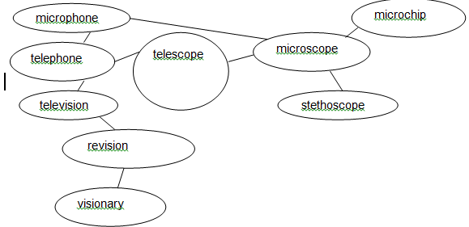
How I help my child with spellings of words that are very similar?
Words that have the same sound but different spellings (such as right and write) are called homophones and are notoriously tricky. There and their is an example that often causes problems. These are good conversations to have…”Which one is it...?”
Words such as ‘hop’ and ‘hope’ and their respective ‘-ing’ suffixes are another, often difficult concept. How do we know whether to double the ‘p’ or not? In fact, there is a clear rule (which the children will be looking at as part of their classroom work but these are conversations that you could have at home).

What if my child has lower literacy skills?
We understand that all children are different, and for some of our pupils the ‘year group’ spelling may not be approrite yet. Don’t worry, your child’s teacher will provide spellings at your child’s level.
Glossary
Noun – an object (door, car, rabbit, piano). These can usually be identified if it is possible to place a/an or the/this at the front.
Verb – a ‘doing’ or ‘action’ word (walk, play, shout, fly). These change depending on the tense (past or present).
Adverb – a word to describe the verb or how the verb is done (quickly, noisily, smoothly, kindly). These words often end in ‘-ly’ but not always.
Adjective – a describing word (large, colourful, floppy, loud).
Syllable – the different parts or beats of a word; e.g, BANANA = BA-NA-NA (3 syllables), LABRADOR = LAB-RA-DOR (3 syllables), BOTTLE = BOT-TLE (2 syllables). This is a helpful way of breaking an unfamiliar word up.
Grapheme – every individual sound within a word; e.g, BANANA = B-A-N-A-N-A (6 graphemes as each letter makes its own sound), BOTTLE = B-O-TT-LE (4 graphemes because the TT is working together to make one sound). This will be taught as another helpful method, especially when trying to write or read unfamiliar words.
Synonym – a word with the same meaning; e.g, a synonym of ‘large’ could be ‘massive’ or ‘gigantic’.
Antonym – a word with the opposite meaning; e.g, an antonym of ‘large’ could be ‘tiny’ or ‘small’.
Over the next few months, it is hoped that the children will become more familiar and confident with this vocabulary and use as part of their spelling lessons. We are always grateful for the time you spend helping your children with their work and we know that many of you will want to support them in what they are learning in class. All members of staff are regularly available if there is anything you want to check and we are always happy to help.
We will be running an afterschool workshop in October to help you further. Details to follow.


