
PARENT HANDBOOK

Dear parents / carers,
World famous rock musicians are the best at what they do because they've spent hours practising guitar chords, writing music or playing on the drums. It's just the same with times tables – all Times Table Rock Stars need to practise and practise and practise.
It's essential that your child does a little bit of times table practice every night. In my experience, short bursts of daily practise are more effective than spending hours once a week.
And this is where you come in. For your child to be fully motivated and for them to get the best out of the practice, they need your help. Without your praise and your reminders, without you sitting down next to them or checking their work, practising times tables will not feel important to your child.
In this handbook, you will find some handy information to help you out and answer any questions your child may have regarding troubleshooting etc. My recommendation is that you are there to help them every evening for half an hour during the first two weeks. This will help to establish a routine. After that, I recommend that you help your child get started for the first 10 minutes and then check on them at the end.
Over the course of the next few weeks and months, your child WILL get faster and more accurate with the times tables. All your hard work and theirs WILL make them a Times Table Rock Star!

Thank you in advance for your time and continued support,

Mr Hassall
Maths Subject Leader


- Type ttrockstars.com into your browser’s address bar or search Times Tables Rockstars in your app store.
- Log in. The school’s details are as follows:
School name: St Andrew’s Junior School, Burnham-on-Sea
Your child has a copy of their username and password in their reading diary.

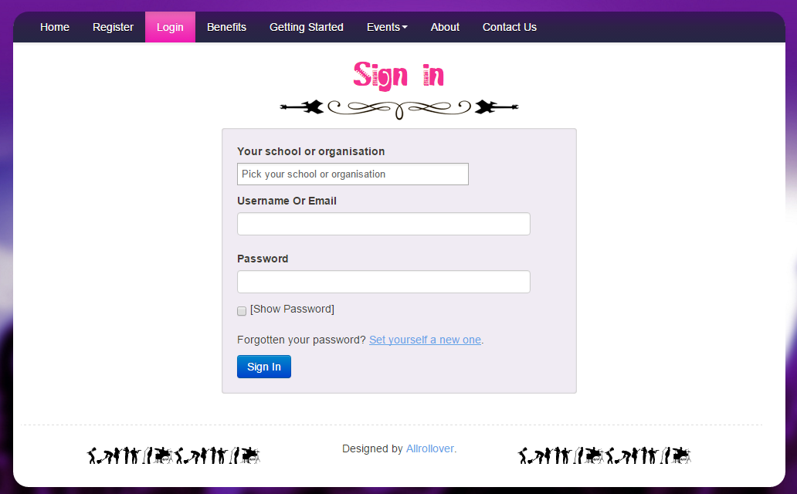
Password goes here
Username goes here
School goes here

- Play!
There are 4 different game modes:
Game Modes
Single Player
Garage - the questions will only come from the times tables the teacher has set for the week. As pupils start to answer questions, TT Rock Stars works out which facts they take longer on and will give them more of these questions to answer. The Garage is best for getting quicker at a few facts. Players get 10 coins per question.
Studio - the questions in the Studio can be anything from 1×1 up to 12×12.
TT Rock Stars calculates each the mean speed from their last 10 games in the Studio and translates into a Rock Status:
≤ 1 sec/qu = Rock Hero  ≤ 2 secs/qu = Rock Legend  ≤ 3 secs/qu = Rock Star  ≤ 4 secs = Headliner  ≤ 5 secs/qu = Support Act  ≤ 6 secs/qu = Breakthrough Artist | ≤ 7 secs/qu = Unsigned Act  ≤ 8 secs/qu = Gigger  ≤ 9 secs/qu = Busker  ≤ 10 secs/qu = Garage Rocker  > 10 secs/qu = Wannabe
They earn 1 coin per question and the Studio is the place for them to set their best time across all the tables.
Multiplayer
Rock Arena - The Arena allows players to compete against all other members of their Band (their Bandmates would need to join the same game in order to compete together). A new Arena game starts every 15 seconds and once the clock starts they race to answer more questions than the others. In the Arena, questions will only come from the times tables the teacher has set for the week, similar to the Garage. They earn 1 coin per correct answer.
Rock Festival - The Rock Festival games are open to players from around the world. Like the Arena, there is no limit to the number of players who can join a game; however, unlike the Arena, questions are selected at random from 1×1 to 12×12. Pupils might choose the Rock Festival if they were playing at home (and therefore couldn't easily synchronise playing against a classmate) or wanted to compete against others not in their Band. They earn 1 coin per correct answer.
The times tables to practice
As a rough guide, these are the tables to practice according to the year group of your child.
Year 2 – 2s, 5s and 10s
Year 3 – 3s, 4s and 8s
Year 4 – 6s, 7s and 9s
Year 5 – 11 and 12s
Year 6 - All tables
Please bear in mind that each school, each class and each child is different.
Your child has times tables already set for them by their class teacher. These will be the tables they are currently working on in the Multiplication Olympics.
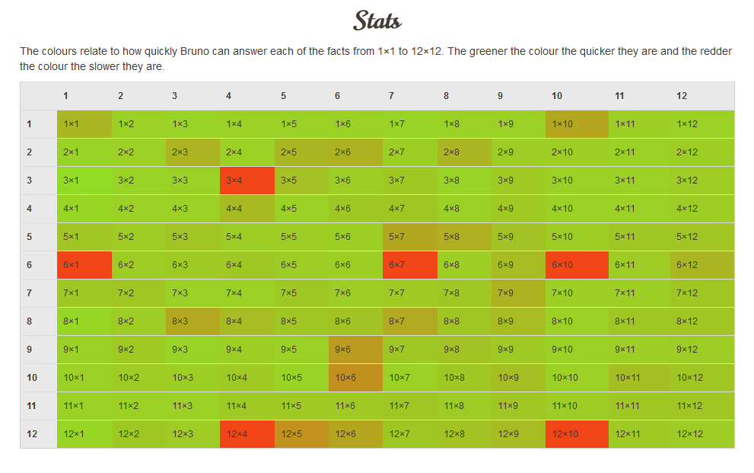
Stats
If you click on Me > My Stats, a heatmap like the one here will load. It shows how successful your child is at each of the facts.

Questions, Problems, Suggestions
Contact your child’s teacher if…
- You have username or password issues
- Something isn’t working or you’re not sure how it works
- You have a complaint or a suggestion
- You have something nice to say about ttrockstars.com!
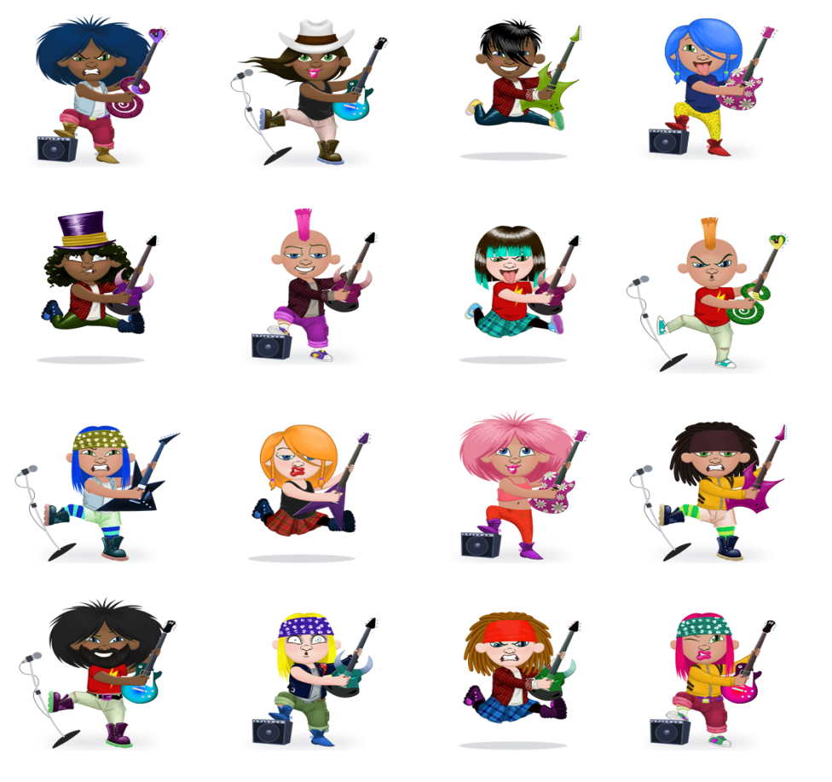
Enjoy!

