Times Tables: 1

Calculation | Cuisenaire | Money (£1 coin(s)) | Result
1 x 1 |  | 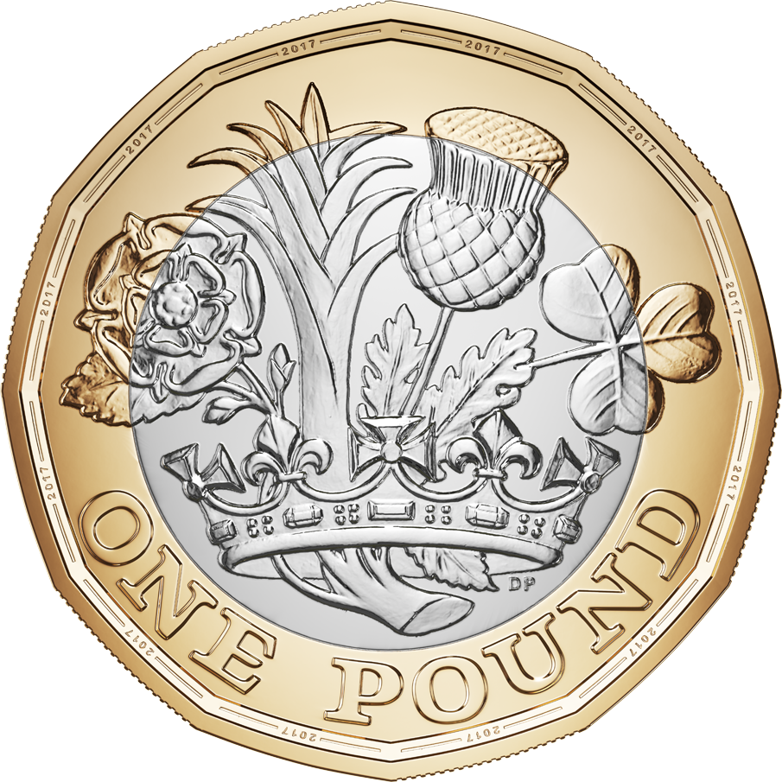 | _______
1 x 2 |  |  | _______
1 x 3 |  |  | _______
1 x 4 |  |  | _______
1 x 5 |  |  | _______
1 x 6 |  |  | _______
1 x 7 |  |  | _______
1 x 8 |  |  | _______
1 x 9 |  |  | _______
1 x 10 |  | 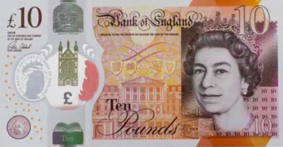 | _______
1 x 11 |  |  | _______
1 x 12 |  |  | _______

Times Tables: 2

Calculation |   Cuisenaire | Money (£2 coins, £10 note) | Result
2 x 1 |  | 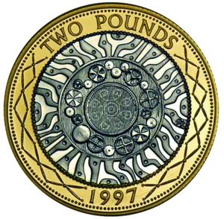 | _______
2 x 2 |  |  | _______
2 x 3 |  |  | _______
2 x 4 |  |  | _______
2 x 5 |  |  | _______
2 x 6 |  |  | _______
2 x 7 |  |  | _______
2 x 8 |  |  | _______
2 x 9 |  |  | _______
2 x 10 |  |  | _______
2 x 11 | 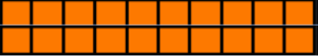 |  | _______
2 x 12 |  |  | _______

Times Tables: 3
Calculation |   Cuisenaire | Tricycle wheels | Result
3 x 1 |  | 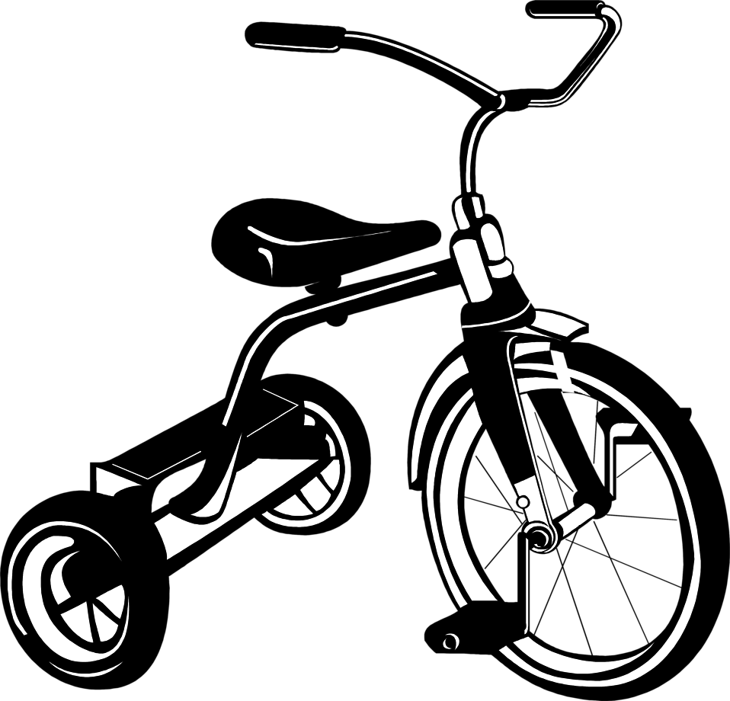 | _______
3 x 2 |  |  | _______
3 x 3 |  |  | _______
3 x 4 |  |  | _______
3 x 5 |  |  | _______
3 x 6 |  |  | _______
3 x 7 |  |  | _______
3 x 8 |  |  | _______
3 x 9 |  |  | _______
3 x 10 |  |  | _______
3 x 11 |  |  | _______
3 x 12 |  |  | _______

Times Tables: 4
Calculation |   Cuisenaire | Racecar tyres | Result
4 x 1 |  | 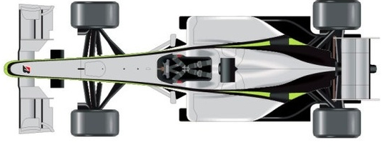 | _______
4 x 2 |  |  | _______
4 x 3 |  |  | _______
4 x 4 |  |  | _______
4 x 5 |  |  | _______
4 x 6 |  |  | _______
4 x 7 |  |  | _______
4 x 8 |  |  | _______
4 x 9 |  |  | _______
4 x 10 |  |  | _______
4 x 11 |  |  | _______
4 x 12 |  |  | _______

Times Tables: 5
Calculation |   Cuisenaire | £5 notes | Result
5 x 1 |  | 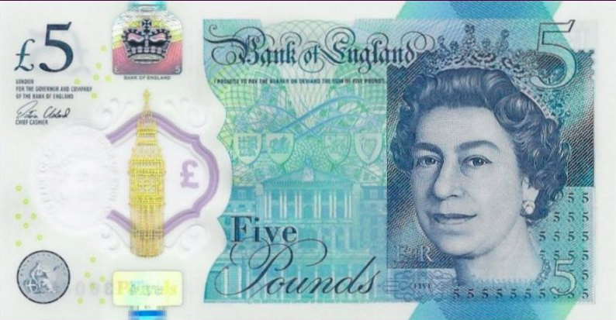 | _______
5 x 2 |  |  | _______
5 x 3 |  |  | _______
5 x 4 |  |  | _______
5 x 5 |  |  | _______
5 x 6 |  |  | _______
5 x 7 |  |  | _______
5 x 8 |  |  | _______
5 x 9 |  |  | _______
5 x 10 |  |  | _______
5 x 11 |  |  | _______
5 x 12 |  |  | _______

Times Tables: 6
Calculation | Cuisenaire | Half a dozen egg boxes | Result
6 x 1 |  | 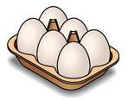 | _______
6 x 2 |  |  | _______
6 x 3 |  |  | _______
6 x 4 |  |  | _______
6 x 5 |  |  | _______
6 x 6 |  |  | _______
6 x 7 |  |  | _______
6 x 8 |  |  | _______
6 x 9 |  |  | _______
6 x 10 |  |  | _______
6 x 11 |  |  | _______
6 x 12 |  |  | _______

Times Tables: 7
Calculation | Cuisenaire | Days of the week | Result
7 x 1 |  |  | _______
7 x 2 |  |  | _______
7 x 3 |  |  | _______
7 x 4 |  |  | _______
7 x 5 |  |  | _______
7 x 6 |  |  | _______
7 x 7 |  |  | _______
7 x 8 |  |  | _______
7 x 9 |  |  | _______
7 x 10 |  |  | _______
7 x 11 |  |  | _______
7 x 12 |  |  | _______

Times Tables: 8
Calculation | Cuisenaire | Octopi | Result
8 x 1 |  |  | _______
8 x 2 |  |  | _______
8 x 3 |  |  | _______
8 x 4 |  |  | _______
8 x 5 |  |  | _______
8 x 6 |  |  | _______
8 x 7 |  |  | _______
8 x 8 |  |  | _______
8 x 9 |  |  | _______
8 x 10 |  |  | _______
8 x 11 |  |  | _______
8 x 12 |  |  | _______

Times Tables: 9
Calculation | Cuisenaire | Spaces on Noughts and Crosses Boards | Result
9 x 1 |  | 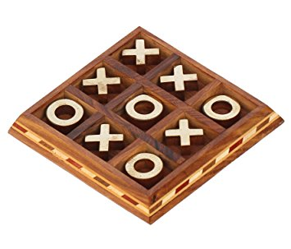 | _______
9 x 2 |  |  | _______
9 x 3 |  |  | _______
9 x 4 |  |  | _______
9 x 5 |  |  | _______
9 x 6 |  |  | _______
9 x 7 |  |  | _______
9 x 8 |  |  | _______
9 x 9 |  |  | _______
9 x 10 |  |  | _______
9 x 11 |  |  | _______
9 x 12 |  |  | _______

Times Tables: 10
Calculation | Cuisenaire | £10 notes | Result
10 x 1 |  |  | _______
10 x 2 |  |  | _______
10 x 3 |  |  | _______
10 x 4 |  |  | _______
10 x 5 |  |  | _______
10 x 6 |  |  | _______
10 x 7 |  |  | _______
10 x 8 |  |  | _______
10 x 9 |  |  | _______
10 x 10 |  |  | _______
10 x 11 |  |  | _______
10 x 12 |  |  | _______

Times Tables: 11
Calculation | Football Teams | Result
11 x 1 | 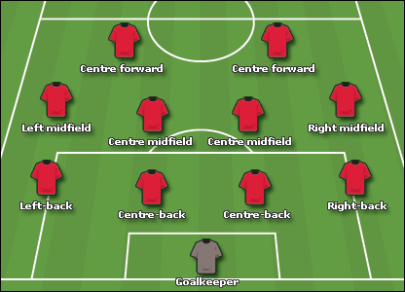 | _______
11 x 2 |  | _______
11 x 3 |  | _______
11 x 4 |  | _______
11 x 5 |  | _______
11 x 6 |  | _______
11 x 7 |  | _______
11 x 8 |  | _______
11 x 9 |  | _______
11 x 10 |  | _______
11 x 11 |  | _______
11 x 12 |  | _______

Times Tables: 12
Calculation | Dozen egg boxes | Result
12 x 1 | 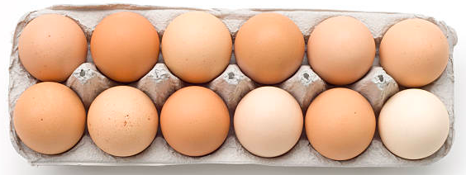 | _______
12 x 2 |  | _______
12 x 3 |  | _______
12 x 4 |  | _______
12 x 5 |  | _______
12 x 6 |  | _______
12 x 7 |  | _______
12 x 8 |  | _______
12 x 9 |  | _______
12 x 10 |  | _______
12 x 11 |  | _______
12 x 12 |  | _______

