Educational apps

Preschool and Kindergarten Learning Games
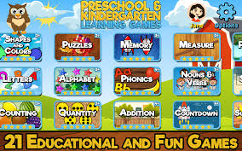

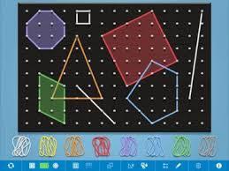
Geoboard

Math Bingo
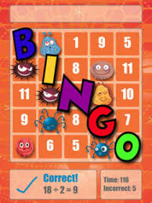

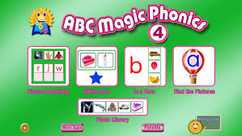
ABC Magic Phonics

Numbler
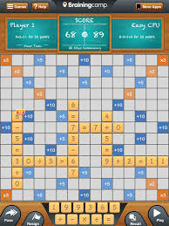

Elmo Loves ABCs
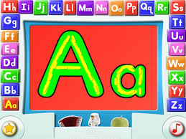

Search: ‘educational apps for kids’ or ‘phonics’ or ‘maths’

