
Year 4
Homework Book
Summer 1

Name: ___________________
Due in: 26th May 2023
Rewards
10 merits for all tasks completed
5 merits for all Mayans tasks completed

Addition and Subtraction
Remember your skills! Can you work the calculation out from these word problems? Do you need to exchange when subtracting? Do you need to carry when adding?

- In one month 382 adults and 65 children stayed in a hotel. How many people stayed at the hotel altogether?

- A tracksuit top costs £12.75 and matching tracksuit bottoms cost £9.50, how much does the tracksuit cost altogether?

- What is the sum of £1.18, £213 and 47p?

- A car park has room for 275 cars. 129 cars are parked in the car park; how many spaces are left?
Maths
Wordsearch
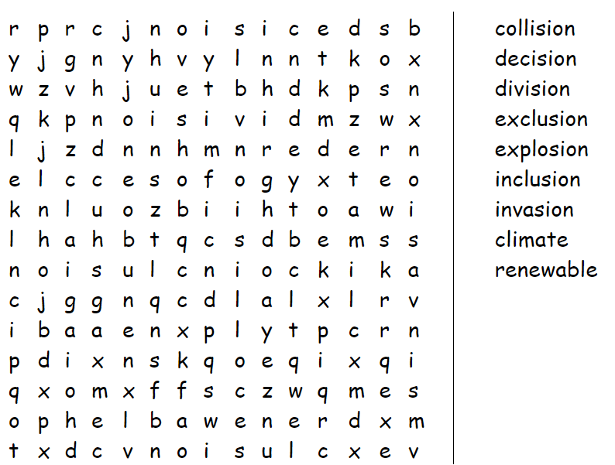
Can you find all of these words? We have practiced these in class!
Spellings

The Mayans
Where about in the world did the Mayan’s live? Can you research and write a paragraph explaining where they lived?

________________________________________________________________________________________________________________________________________________________________________________________________________________________________________________________________________________________________________________________________________________________________________________________________________________
________________________________________________________________________________________________________________________________________________________________________________________________________
History
Common Errors
English
Read through the sentences below and correct the single spelling, grammar or punctuation error in each one. These errors often appear in students’ work.
1) They like football alot.
2) John is he’s friend.
3) The pea’s were delicious.
4) “Be quite,” said the teacher.
5) I live just passed the supermarket.
6) Whose that woman over there?
7) We never go nowhere in winter.
8) Lucy said she seen the thieves running away.
9) They cooked the meal theirselves.
10) Do you like swimming.
11) The cat licked it’s lips.
12) Tim writes very quick.
13) I would of made you a cup of tea if you’d asked.
14) Its been a long day.
Handwriting
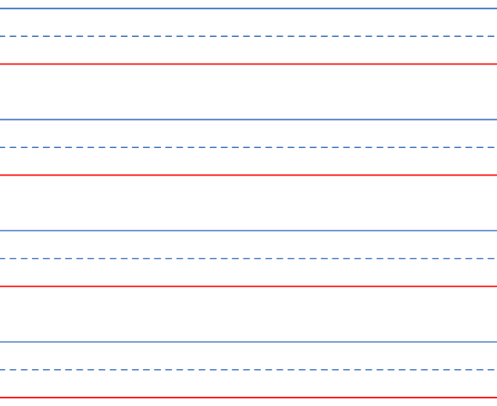
Can you practice writing the following words? Capital letters fit between the top blue line and the bottom red line, lowercase letters between the dotted line and the red line.

church, school, house, office
Handwriting
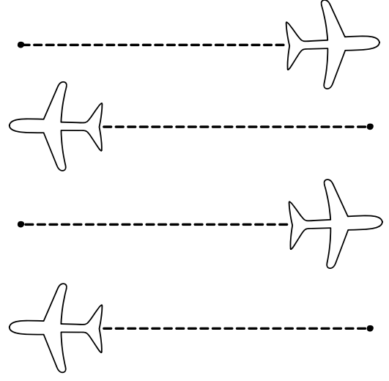
Pencil Control
Handwriting
Division
Can you use bus stop method to answer these word problems? If you can’t remember how, what other method could you use?
Maths
- I cut my cake into 16 pieces to share with my friends. There are four of us altogether. How many pieces will we each get?


- There are 48 potatoes left in the pan and 4 children in the queue. How many potatoes will they each get?

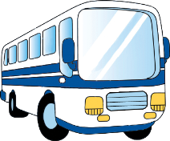
- 64 children need to go to the swimming baths. Two buses are sent to take them there. How many children should go on each bus?

- A supermarket has 4 shelves for soup and 84 tins to put on them. How many tins should they put on each shelf?

Wordsearch
Can you find all of these words? We have practiced these in class!
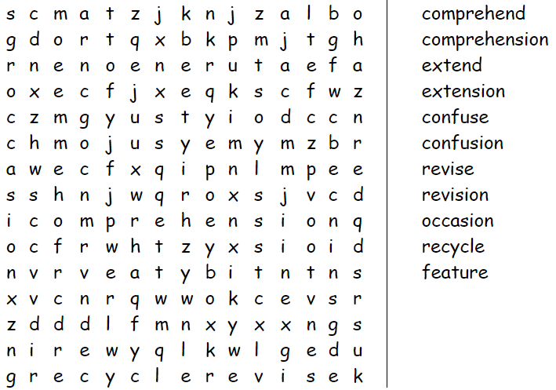
Spellings
The Mayans
Can you draw or make a Mayan temple? Write about why the temples were so important to the Mayans.
History
________________________________________________________________________________________________________________________________________________________________________________________________________________________________________________________________________________________
Capital Letters, Full Stops & Commas
Read through the short story below. It is missing a) beginning-of-sentence capital letters, b) capital letters for the ‘I’ pronoun, c) full stops, and d) commas. Can you correct this story?
English
when we reached the cinema we found it was awfully busy the queue to buy tickets ran out of the entrance and all the way round the building thankfully we had bought our tickets online the website let us print them at home which meant we didn’t have to queue at all we went straight through to the screen and sat down in the comfortable chairs i was so relaxed i almost fell asleep during the trailers
when the film started i was annoyed at the number of people crunching popcorn and slurping fizzy drinks they were quite noisy and didn’t seem very interested in the film perhaps i was jealous because i was actually very hungry the film was excellent though and it soon took my mind off my appetite it was about a man who gets struck by lightning and then discovers he can communicate with plants and animals he has many strange and funny experiences my favourite part is when he finds out what his pet cat really thinks of him the ending was quite unexpected but extremely clever
Handwriting
Can you practice writing the following words? Capital letters fit between the top blue line and the bottom red line, lowercase letters between the dotted line and the red line.
pencil, pen, sharpener, ruler
Handwriting
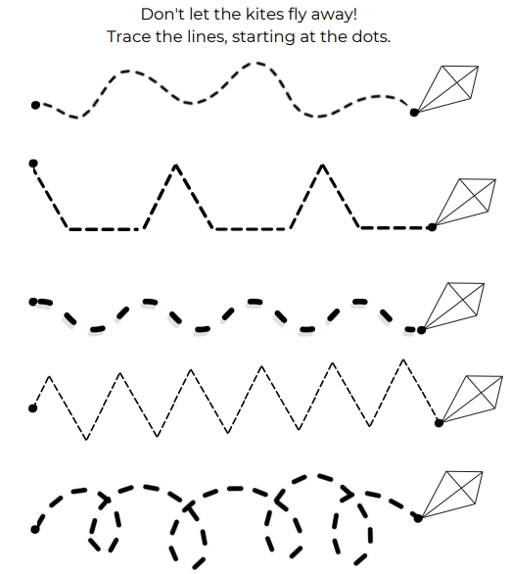
Pencil Control

Multiplication
Handwriting
Can you use your chosen method to answer these word problems?

- Mr Panter has to replace 6 light bulbs in each classroom. There are 14 classrooms. How many light fittings does he need to change?

- The younger classes got free strawberries on Friday for snack. There are 46 children in the area and they needed 4 strawberries each. How many altogether did the dinner ladies need?

- The box of chocolates has 28 sweets on each layer and 3 layers. How many chocolates altogether in the box?
Maths

Wordsearch
Can you find all of these words? We have practiced these in class!
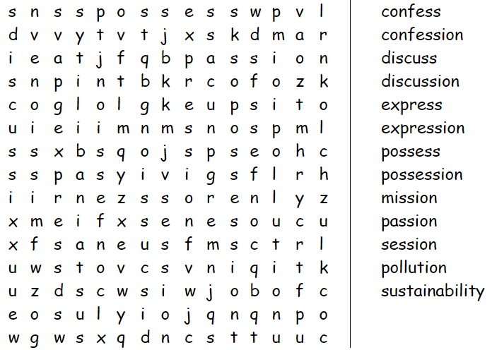
Spellings
The Mayans

The Mayan’s loved chocolate. Think about your favourite chocolate treat? Design a wrapper for a new chocolate bar you have invented.
History
Book Review
Can you complete a book review of your favourite book?
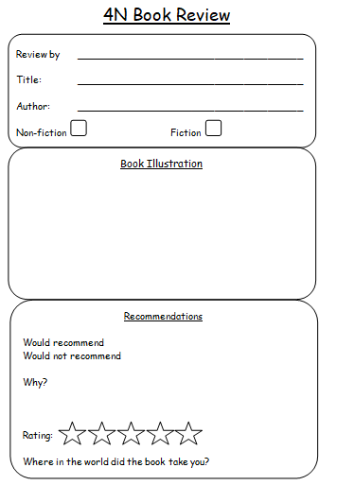
Handwriting
English
English
Can you practice writing the following words? Capital letters fit between the top blue line and the bottom red line, lowercase letters between the dotted line and the red line.
thirteen, fourteen, fifteen, sixteen
Handwriting

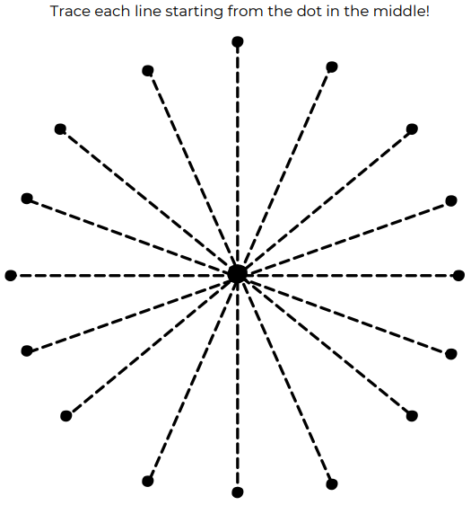
Pencil Control
Handwriting

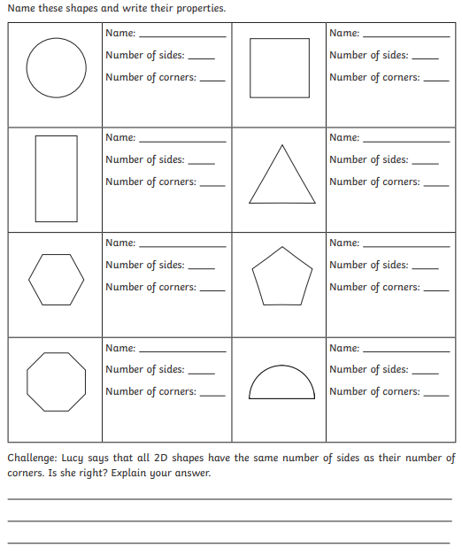
Shape
Maths
Wordsearch
Can you find all of these words? We have practiced these in class!
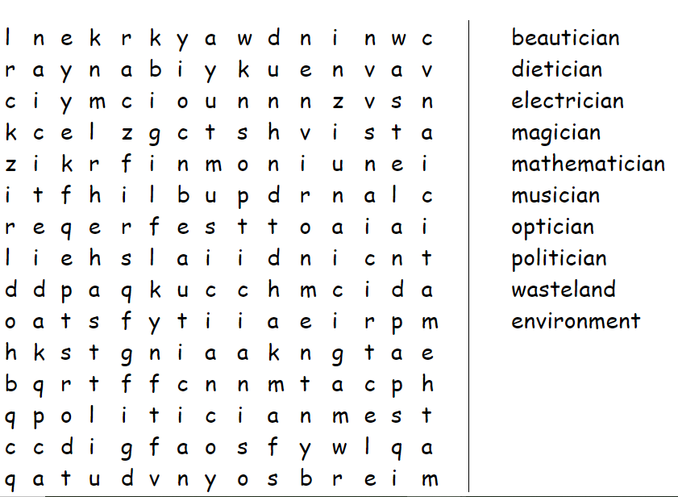
Spellings
The Mayans
Can you find out about the Mayan calendar? What was it? Write about what you can find out!

________________________________________________________________________________________________________________________________________________________________________________________________________________________________________________________________________________________________________________________________________________________________________________________________________________
History

Conjunctions
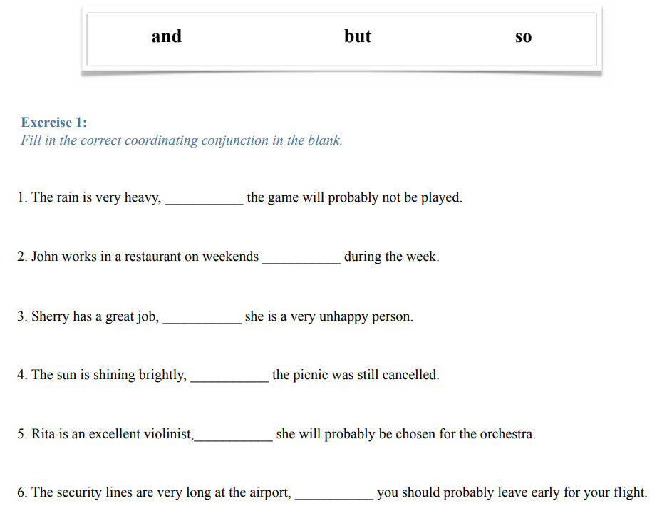

English

Handwriting
Can you practice writing the following words? Capital letters fit between the top blue line and the bottom red line, lowercase letters between the dotted line and the red line.
Scotland, Ireland, Wales, England
Handwriting

Mayan Colouring
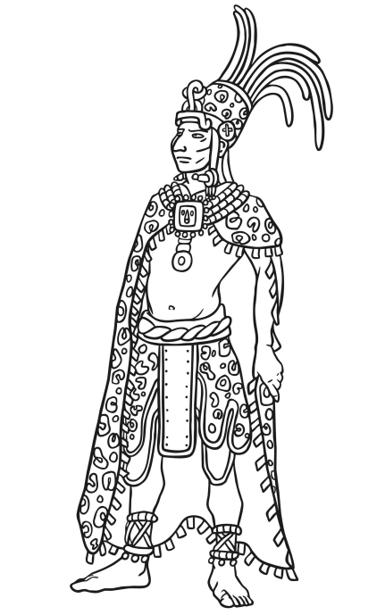
Art
Commas
Copy these sentences, putting in the missing commas. Remember, a comma helps break up longer sentences into smaller parts to make more sense.

1. A hedgehog is small with a spiny body.
2. Bob closed his book glad that the maths lesson was over.
3. The car a red car zoomed past them.
4. Mum parked in the car park near the bank.
5. The taller of the two ladies the one with green hair was the one who was shouting.
6. I would like an ice cream a vanilla one.
7. Have you seen Sid my little dog?
8. After stopping for a drink the hikers moved off.

English
Wordsearch
Can you find all of these words? We have practiced these in class!
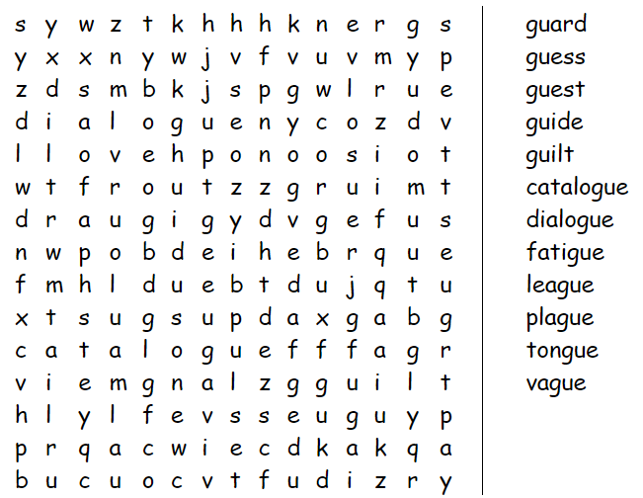
Spellings
The Mayans
The Mayans were great farmers and enjoyed eating tortillas filled with cooked vegetables! Can you design your own Mayan tortilla recipe? Perhaps you could even make it and take a photo!
History
Identifying angles
Can you identify the following angles? They are either acute, obtuse, reflex or a right angle.
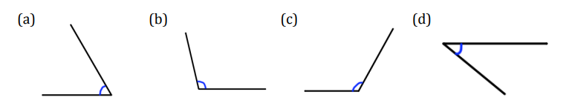
Maths
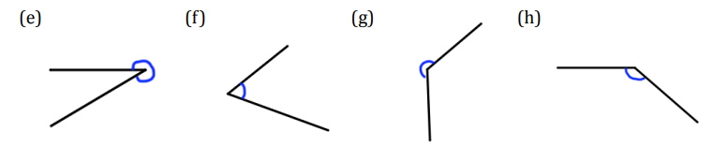
Handwriting
Can you practice writing the following words? Capital letters fit between the top blue line and the bottom red line, lowercase letters between the dotted line and the red line.
door, window, roof, patio
Handwriting

Mayan Colouring
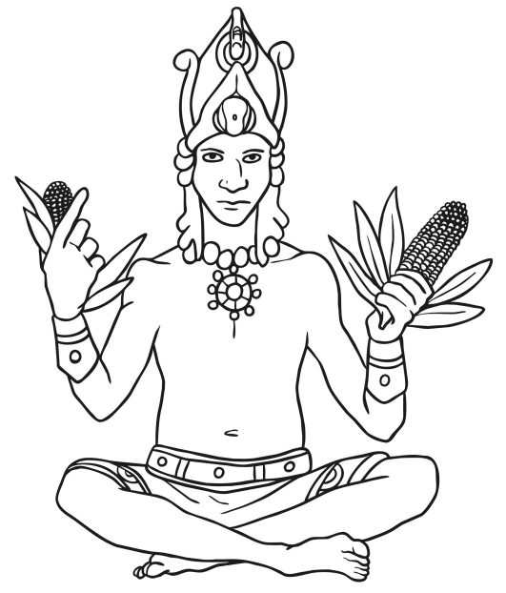
Art
Hopes and wishes
What are you going to do in your half term holiday? What do want to achieve or learn?

________________________________________________________________________________________________________________________________________________________________________________________________________________________________________________________________________________________________________________________________________________________________________________________________________________________________________________________________________________________________________________________________________________________________________________________________________________________
Secrets of Success

