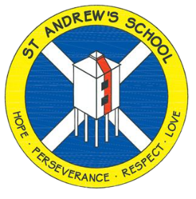
St Andrew’s Church of England Junior School
Unit Overview
At St Andrew’s our vision statement is ‘Shining Light on a World of Possibilities’ and we have designed our curriculum to be relevant, exciting and creative, underpinned by our school values and based around our ‘curriculum drivers’:
Subject : |  | Science
Unit Title |  | Light
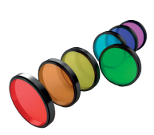
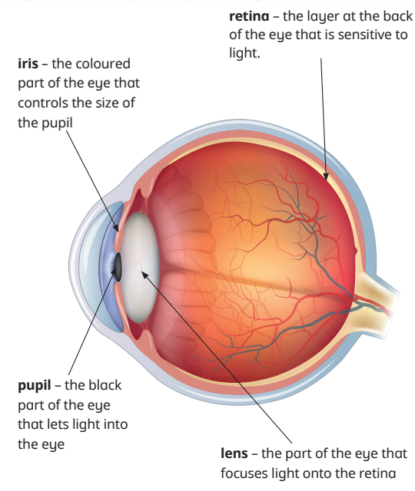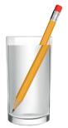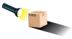
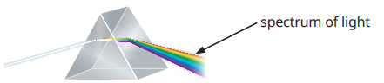
Main Learning Outcomes from the unit:
We need light to be able to see things. Light travels from its source in straight lines. Light is reflected off objects to enable us to see them. Light can be blocked and shadows are formed. Light can also bend as it travels from air to water (refraction)
During this unit children will learn:
- How we see things, parts of the eye.
- That light travels in straight lines, but it can change direction if it is reflected.
- How shadows are formed, and investigate how a sundial works.
- To use the terms, opaque, translucent and transparent accurately
- To investigate changing the size of shadows. Planning a fair test, recording data accurately and presenting results.
- What is refraction? Does the speed light travels in change?
- That white light can be separated into different colours using a prism.
Key Vocabulary for this Unit:
Light source  Retina  Iris  Pupil  Lens  Reflection  Ray diagram  Angle | Periscope  Shadow  Opaque  Translucent  Transparent  Solar eclipse  Refraction  Medium |  | Lens  Rainbow  Prism  Coloured filter  Spectrum of light  Independent variable  Dependent variable  Controlled variable
Assessment:
- What is the pupil, retina, lens and iris? What is their fuction?
- How does light travel? What does reflection mean?
- Why do we see shadows when light is blocked by an object? Can the shadows shape change?
- What does transparent, translucent and opaque mean?
- What happens when light travels from air to water?
- What is a spectrum of light?
•Curiosity, enquiry and creativity •Community •Possibilities

