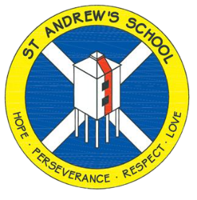

St Andrew’s Church of England Junior School
Unit Overview
At St Andrew’s our vision statement is ‘Shining Light on a World of Possibilities’ and we have designed our curriculum to be relevant, exciting and creative, underpinned by our school values and based around our ‘curriculum drivers’:
•Curiosity, enquiry and creativity •Community •Possibilities
Subject : |  | Geography
Unit Title |  | Burnham-On-Sea
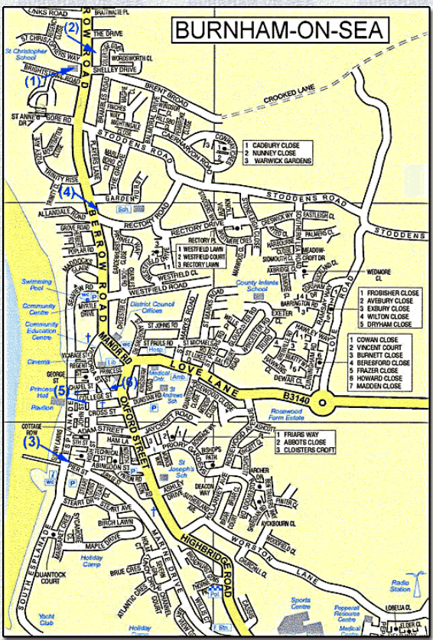
Main Learning Outcome from the unit:
To know the role of Burnham-On-Sea within the local area and to understand the human and physical geography of the area.
During this unit children will learn:
- The role of economic activity in Burnham-On-Sea
- Land use in Burnham-On-Sea
- Understand Burnham-On-Sea as a settlement
- Climate zones of Burnham-On-Sea and compare them to other countries
- The physical geography of the local area.
Key Vocabulary for this Unit:
Economics  imports  exports  industry  products | natural resources  human geography  residential  Industrial |  | settlements  commercial  markets  ports
Assessment:
Write a summarising paragraph about the role of Burnham-On-Sea within the local area.

