

St Andrew’s Church of England Junior School
Unit Overview
At St Andrew’s our vision statement is ‘Shining Light on a World of Possibilities’ and we have designed our curriculum to be relevant, exciting and creative, underpinned by our school values and based around our ‘curriculum drivers’:
•Curiosity, enquiry and creativity •Community •Possibilities
Subject : |  | RE
Unit Title |  | What do Christians believe about Salvation?

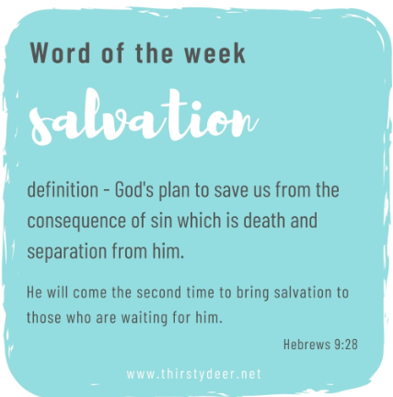
Main Learning Outcome from the unit:
To understand why Salvation is important in Christianity.
During this unit children will learn:
- To understand what Salvation means and what impact it has.
- To understand that redemption and atonement are crucial in Christianity.
- To understand why Salvation is important.
- To understand why communion is important
- To understand how prayer links to atonement.
- To understand the difference between an infant and believer’s baptism.
- To understand what impact forgiveness can have.
Key Vocabulary for this Unit:
Atonement  forgiveness  resurrection  death  Christ  communion | Lord  Christian  saviour  sacrifice  forgiveness  prayer |  | sin  redemption  Last Supper  Easter  Bible  Good Friday
Assessment:
Why is forgiveness important in Christianty?

