SUMMARY OF MATHEMATICAL TERMS, YEAR 6
 | DEFINITION | EXAMPLE
ACUTE ANGLE | An angle less than 90 | 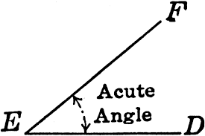
ANALOGUE | Non-digital clock (second, minute and hour hands) | 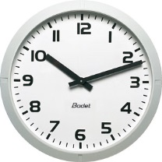
AREA | The amount of space inside a shape | Triangle: ½ LENGTH X HEIGHT  Rectangle: LENGTH X HEIGHT
AVERAGE (MEAN) | Add up total of the numbers and divide by the amount of numbers | 3 + 12 + 6 =21  (divide by 3)  Average = 7
DENOMINATOR | Bottom number of a fraction | 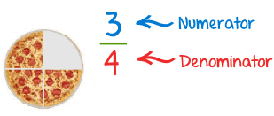
DIAMETER | The length of the line across the middle of a circle | 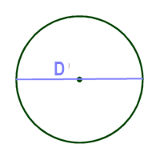
DIFFERENCE | Subtract
EQUILATERAL TRIANGLE | Triangle with 3 equal sides and angles (all angles = 60 ) | 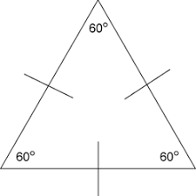
FACTOR | Usually in pairs, the times tables that a number appears in | Factors of 24  1 x 24  2 x 12  3 x 8  4 x 6
FREQUENCY | The amount of times something happens
IMPROPER FRACTION | Fraction where the numerator is greater than the denominator | 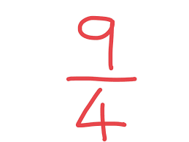
INTEGER | Any whole number
INVERSE | The reverse calculation of what has just been done
ISOSCELES TRIANGLE | Triangle with 2 equal sides and angles | 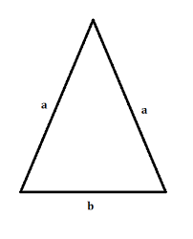
MULTIPLE | The numbers that are in a times table | Multiples of 8:  8, 16, 24, 32, 40, 48, 56, 64, 72, 80
NUMERATOR | Top number of a fraction
OBTUSE ANGLE | An angle greater than 90 | 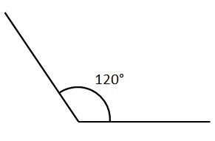
OPERATION | Type of sum that is being performed | 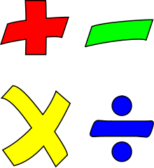
PARALLEL | Lines that remain the same distance apart | 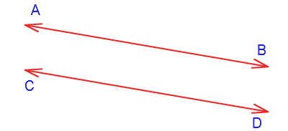
PARALLELOGRAM | A type of quadrilateral | 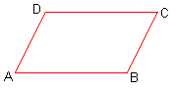
PENTAGON | A 5-sided shape | 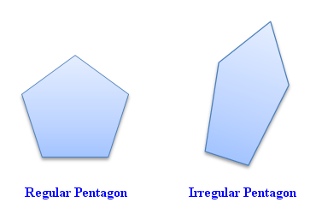
PERIMETER | The length around the outside of a shape
PERPENDICULAR | Lines at right angles to one another | 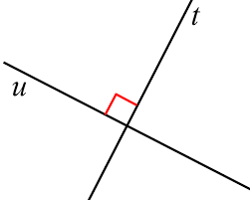
POLYGON | A plain shape with at least two straight sides
PRIME NUMBER | A number that does not appear in any times tables (other than its own and 1) | 2, 3, 5, 7, 11, 13, 17, 19, 23, 29, 31, 37, 41, 43…
PRODUCT | Multiply
QUADRILATERAL | A 4-sided shape
RADIUS | Half a diameter  (the distance from the middle of the circle to the edge) | 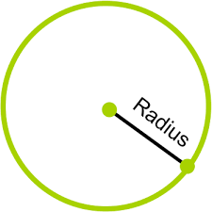
RATIO | The size or relationship between two different values
RECTILINEAR | Any shape in the rectangle family | Square  Rectangle  Parallelogram
REFLEX ANGLE | An angle greater than 180 but smaller than 360 | 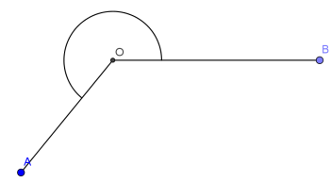
RIGHT ANGLE | A 90 angle | 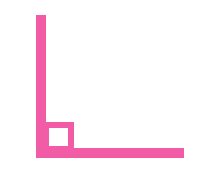
ROTATE | Turn
SCALENE TRIANGLE | Triangle with no equal sides or angles | 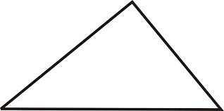
SIMPLIFIED FRACTION (SIMPLEST FORM) | A fraction where the top and bottom number cannot be made any smaller | 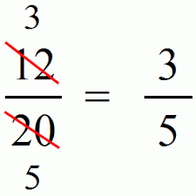
SQUARE NUMBER | A number multiplied by itself | 1, 4, 9, 16, 25, 36, 49, 64, 81, 100, 121, 144…
SUBTRACT/ SUBTRACTION | Take away
SUM | Add
TOTAL | Add
TRANSLATE | Move a shape
TRAPEZIUM | A type of quadrilateral | 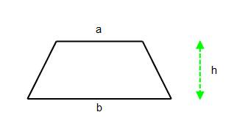
VERTEX/ VERTICES | Corner
X-AXIS
Y-AXIS
I | 1
V | 5
X | 10
L | 50
C | 100 (CENT)
D | 500
M | 1000 (MILLENNIUM)
1M = 100CM 1000 ML = 1 L
1CM = 10MM 1000G = 1KG



