Special Educational Needs (SEN) Information Report 2026 – 2027

Shared Trust Ambition: Achieving a great education for every child

‘Shining Light on a World of Possibilities’





Our Vision
We aim for each child to:

Know they are unique and special.
Be a highly motivated, skilled and resilient learner.
Be a respectful and tolerant global citizen, learning to live together with others.
Have a spiritual experience of Christian life and worship.

It is our ambition at St. Andrew’s that every child with SEND reaches their full potential and can make a successful transition into higher education, training, work and our community.

This document will tell you how we support children with Special Educational Needs and/or Disabilities (SEND) at St. Andrew’s Junior School. It has been co-written with input from parents, staff, and pupils at the school.

Date: June 2026
Review date June 2027
What Ofsted said 

Pupils with SEND take part in all aspects of school life. Leaders have put in place robust procedures to identify pupils who may need extra support. As a result, pupils receive effective support with their learning from well-trained staff. The transition process for pupils with SEND newly arriving at the school is effective and, consequently, they settle quickly – St. Andrew’s Junior School Ofsted Report 2022

What SIAMS said

Inspired by the Christian vision, provision and care for pupils who have special educational needs and/or disabilities (SEND) or who are deemed to be vulnerable, are exceptional. This demonstrates the school’s commitment to enabling pupils to flourish. – St. Andrew’s Junior School SIAMS ( Statutory Inspection of Anglican Schools) report 2026
What pupils say (Pupil voice Summer2026) 

I like being able to use the Lighthouse at lunchtime because the hall is so busy and I don’t like that’
‘Mrs Ratcliffe helped me to actually like and be able to read’’
‘I use the regulation station every day to help me be ready for learning. It is a good place to go when you have dinosaur brain’
‘Using the Lighthouse in the mornings when coming into school has been scary is good, Ms Robb is kind and helps me’

What parents say ( Parent voice Spring 2025) 

The teachers are working hard to support my child
Mrs Thomson to us and has helped X get the support he needs.’
‘X has had good support since starting at ST. Andrew’s and we like that all the staff are friendly, kind and want to help’

SEND Support

- At St. Andrew’s Junior School, Special Educational Needs and Disabilities (SEND) is seen as a whole school responsibility and all systems and structures reflect this.

- The St. Andrew’s Junior School’s Special Educational Needs Co-ordinator is Tamsin Thomson - Tamsin.thomson@saja.theplt.org.uk
Other staff who support SEN Support directly with interventions that are ‘additional to and different from’ (SEN Code of Practice 2014) universal support are
Mrs Ratcliffe – Cognition and Learning Interventions
Mrs Haines – Outdoor Adventure Intervention
Ms Robb – Emotional Literacy Support
Mrs Dawes – Drawing and Talking and Communication and Interaction

- Our SEND provision allows pupils with additional needs the opportunity to follow an inclusive curriculum specifically tailored to develop growth mindset, resilience and independence.

- From September 2026, we will also have the Harbour Provision which will be staffed by Mrs Haines and Mrs Hodgkinson. The Harbour provision is an alternative learning support base in our mainstream school to support those in our mainstream school with high need and EHCPs who find the busy mainstream classroom difficult to access for various reasons.

- From January 2026, we will also be opening a specialist KS2 support base for children with the designation of Cognition and Learning and Communication and Interaction Needs. This is a specialist provision on our mainstream Junior School site accessed through the EHCP consultation process at county only.

Who is responsible for meeting the needs of a pupil with SEND at St. Andrew’s?

Class Teacher   | Responsibilities include:  - Planning, teaching/delivering high quality inclusive lessons suited to your child’s needs  - Assessing/monitoring progress and identifying the next steps to take them forward in their learning.  - Using and drawing up Assess, Plan, Do Review (APDR) documents for pupils with SEND in consultation with parents and if necessary SENCo. These have individual targets and are very specific to the individual pupil and may be small steps, working towards a bigger overall target.  - Identify when additional support is needed  - Ensure that all staff working with a pupil are supported to deliver planned work so that they can achieve the best possible progress. This may involve the use of additional adults (Education Support Assistants).
SENCo  Mrs Thomson   | Responsibilities include:  - Co-ordinating all the support for pupils with SEN and developing/implementing SEND Policy to make sure all pupils get consistent, high quality response to meeting their needs in school.  - Ensuring that all staff working with a pupil are  - Involved in supporting their learning  - Kept informed about the support given  - Involve parents in reviewing how they are doing  - Liaising with all the other people who may be coming into school to help support your child’s learning. E.g. Speech and Language Therapy, Educational Psychologist etc.  - Completing and sending off any referral forms for those services (which will be done with parental consent)  - Updating the school’s SEND register (a system for ensuring all the SEND needs of pupils in this school are known) and making sure that there are excellent records of pupil’s progress and needs.  - To provide specialist support for teachers and support staff in the school so they can help pupils achieve the best possible progress in school.  - Ensure all SEND legislations and guidance on duties are being followed – e.g. Children and Families Act 2014, Code of Practice 2014, Somerset’s graduated response.
Headteacher  Mrs Hatch   | Responsibilities include:  - The day to day management of all aspects of the school, this includes the support for pupils with SEND.  - Ultimately ensuring that pupil’s needs are met  - Ensuring the Governing Body is kept up to date about issues in the school relating to SEND
SEND Community Councillor  Mrs Andrews   | Responsibilities include:  - Making sure the SEND Policy is being implemented in school  - An awareness of the SEND Code of Practice and monitoring this within school.  - Having a strategic view (pupils are not individually identified by name)

St. Andrew’s Junior School SEND profile

Types of support | Percentage of students
 | 2024 | 2025 | 2026
Special Educational Needs (SEN) Support | 12.73% | 14.92% | 9.2%
Education, Health Care (EHC) plan  (including those awaiting their draft and issue) | 3.33% | 3.8% | 9.25%

Types of SEND need at St. Andrew’s Junior School

Broad Area of Need | Need Type ( not an exhaustive list) | Percentage of students June 2026
Communication and Interaction   | Speech and language difficulty  Communication and interaction difficulty  Developmental language disorder  Stammer | 2.74%
Cognition and Learning   | Dyslexia  Specific difficulties in literacy  Dyspraxia/DCD  Global developmental delay  Moderate/mild learning difficulty | 7.19%
Social, Emotional, Mental Health (SEMH)   | Attention deficit hyperactivity disorder/Attention deficit disorder  Attachment difficulties/multiple ACES  Anxiety disorder  Obsessive compulsive disorder  Tourette’s syndrome  Emotional difficulties)  Emotional and/or Conduct difficulties  Autism Spectrum Condition | 6.85%
Sensory and/or Physical   | Vision impairment  Hearing impairment  Multi-Sensory impairment  Physical disability  Sensory processing difficulties  Cerebral Palsy | 1.03%

Important Links

SEND policy and Accessibility Plan can be found here: https://www.cset.co.uk/policies/

SEND policy and Accessibility Plan can be found here: https://www.theplt.org.uk/page/?title=Policies&pid=43

Somerset’s Local Offer https://www.somerset.gov.uk/children-families-and-education/the-local-offer/

Question | Response
How does the school decide if my child needs extra help?   | At St. Andrew’s we use the definition for SEN and for disability from the SEND Code of Practice (2014) and we follow the Somerset Graduated response tool to decide when a child needs SEN support.  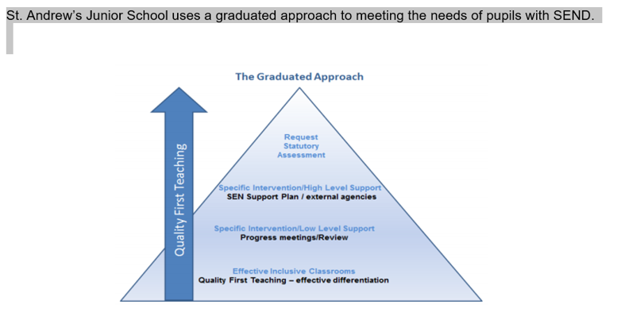  The Somerset Graduated Response Tool  High quality teaching (universal support) underpins the graduated response and all educational provision. The Graduated Response Tool (SGRT) describes the entitlement of children and young people with Special Educational Needs and Disabilities (SEND) in early year’s settings, schools and further education in Somerset.  You can learn more about Somerset’s Graduated Response Tool at:  https://somersetsafeguardingchildren.org.uk/publication/graduated-response-tool/  At St. Andrew’s Junior School, the Somerset Graduated Response Tool (SGRT) is embedded into our whole school approach to supporting pupils with SEND. Teachers will regularly use the tool at a Universal and SEN support level to help them use the most effective strategies to support children with different areas of SEN and to know what they could try next to help a child make progress to learn and achieve effectively. Below is a video link to explain the Somerset Graduated Response Tool (SGRT)  https://www.youtube.com/watch?v=w_31z12tfQM  It is important to note that support and provision at St. Andrew’s is needs not diagnosis based. We do not need to have or wait to have a diagnosis of anything to work hard with parents to remove any barriers to learning and support a child in our setting to learn and achieve successfully. This is what the SGRT helps us to do.  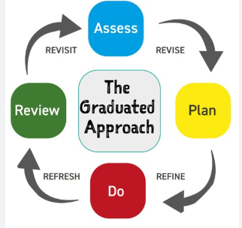  - Staff will seek to identify the needs of pupils with SEND through the Assess, Plan Do, Review Cycle with a strong emphasis on child and parent/carer views.  - Teachers will provide inclusive high quality teaching. This acts as the baseline for learning for all pupils. All teachers must be committed to reducing barriers to learning for pupils with SEND, by planning work which is appropriately adapted and includes strategies from the school’s provision map, including visual timetables, and visual symbols to aid communication.  - Specialist equipment may also be used for individual pupils, including wheelchairs, writing slope etc. teachers and support staff will receive training on aspects of the SEND during INSET days, staff meetings and external courses. Staff will liaise with the SENCo where extra support or advice is needed. In line with the SEN Code of Practice, the majority of pupils will have their special education need met in class and have access to a broad and balanced curriculum.  - All staff work extremely hard to create an effective and inclusive learning environment to support neurodiversity as well as specific learning difficulties or delays or disability, e.g. autism, ADHD and Dyslexia friendly classrooms.  - Teachers and staff monitor the progress of all pupils in order to aid the identification of pupils with SEN. Continuous monitoring of pupils with SEN by their teachers will help to ensure that they are able to reach their full potential. Pupils with SEN often have knowledge of their own needs and we would seek their views about what sort of help they would like. We will encourage them to share in the outcomes aimed for and review meetings where appropriate.  - We liaise closely with parents and get their views along with the views of pupils with SEND themselves  - We work with, and seek appropriate support from outside agencies when the needs of the student cannot be met by the school alone, for example Speech and Language Therapists, Educational Psychologists, Occupational Therapists etc.  - We ensure that pupils with SEN engage in the activities of the school alongside pupils who do not have SEN.  - We strive to create an inclusive school environment where pupils contribute to their own learning and develop independence.  - We review a pupil’s progress at regular intervals with the child, their parents/carers and any professional who supports the pupil. This is done at parents’ evenings for all pupils, at APDR meetings for pupils on SEN support and at annual review meetings for pupils with EHCPS and High Needs funding.  - The impact and quality of the support also is also measured and reviewed within the school.
What should I do it I think my child has Special Educational Needs? | In the first instance, please talk to your child’s class teacher. Effective communication between school and families is essential. We will use the Somerset Graduated response tool to look at provision that may need to be in place to support a child. The parent and class teacher will start by using a Quick checker from the SGRT to identify any areas of SEN need.  We recognise that parents know their children best and are keen to listen to their views to ensure a child is able to learn and achieve successfully.  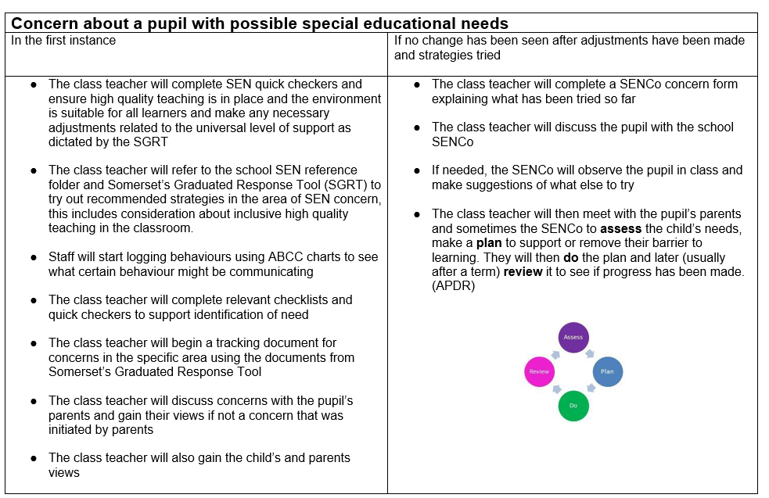
How will the school consult with me and how can I be involved in planning their support?  How will my child be involved in planning the support they will have?   | - Pupil voice’ interviews form part of our monitoring process where small focus groups of children give their views on a variety of topic to the Leadership Team and Subject Leaders.  - The School Parliament invite the children to suggest improvements to the school through posted ideas in a class box, which are then discussed at meetings.  - The SENCo and/or class teacher will meet with pupils in order to get their views either during or before an APDR (Assess, Plan, Do, Review) meeting.  - We value working in partnership with parents/carers to gain better understanding of their child and involve them in all stages of their child’s education. This may include supporting parents in understanding SEN provisions and procedures and enabling them to support the child at home with their learning. Parents are consulted during the writing of EHC plans, annual reviews, pupil passports and Assess, Plan, Do, Review (APDR) documents.  - APDR meetings happen termly with parents to review and set new targets on a child’s learning plan at SEN support and high needs level.  - We welcome regular contact through emails and phone calls and home/school books where appropriate. Partnership with parents plays a key role in enabling children with SEN to achieve their potential. The school recognises that parent/carers hold key information and have knowledge and experience to contribute to the shared view of a child’s needs and the best ways of supporting them successfully.
How do you know if my child is making progress?  How will I be aware of my child’s progress?   | - As a school we measure pupil progress in learning against national age related expectations as well as against a child’s starting points and small steps progress as part of the APDR process.  - The class teacher continually assesses each pupil and notes areas where they are improving and where further support is needed. We track pupil progress from their admission in Year 3 through to Year 6, using a variety of different methods, including assessment under the New National Curriculum and some standardised tests, as appropriate.  - Pupils who are not making expected progress are identified through the termly Pupil Progress Meetings. In this meeting a discussion takes place about those pupils experiencing difficulties and what further support can be given to aid their progress.  - The SENCo monitors the effectiveness of the provision made for Children with SEND through learning walks, classroom observations, regular meetings with class teachers and Education Support Assistants and analysis of class data and SEN learning plans.
How will the curriculum be matched to meet my child’s needs? | St. Andrew’s works hard to ensure our curriculum is fully accessible and inclusive through lesson planning and delivery. Teachers plan lessons to meet the needs of individual learners using knowledge of each student in their class including their strengths, barriers and interests. Lesson adaptations and reasonable adjustments are put in place to ensure all can access learning successfully.
How will information about my child’s special educational needs or disability and the support they will need be communicated to staff? | St. Andrew’s staff work well with a team around the child approach and ensure there is effective communication with the team and parents through regular phone calls and emails. Each pupil on SEN support also has a pupil passport where key information is co-written with the child and parents as well as the teacher and shared with staff. Regular meetings are held with all members of the team as well as parents as part of the Assess, Plan, Do and Review process.
What training do teachers at St. Andrew’s receive about working with children with SEND? | - All staff have received Safeguarding Training.  - Staff have been trained in Positive Handling approaches and de-escalation techniques in order to support children with SEMH difficulties.  - A number of teachers and ESAs are trained to support children with medical needs such as diabetes.  - All staff have had Epilepsy training  - Some of our ESAs are trained in literacy and phonic strategies, ILI (Individual Literacy Intervention) and Spelling Development.  - A number of our teachers have had additional training in phonics through Sounds Write and Unlocking Letters and Sounds  - Staff have had training in Dyslexia awareness and creating a dyslexia friendly school  - Staff have had training on learning without limits and growth mindset  - Staff have had training on effective questioning and Precision Teaching  - Staff have had training on Attachment and developmental trauma  - Staff have had training on emotion coaching  - Staff have had training on ADHD and classroom strategies  - Staff have had training on Autism Awareness and classroom strategies and are all trained at a Good Autism Practice level recognised by the Autism Education Trust  - Staff have received training in supporting pupils who have experienced trauma and domestic abuse  - Staff have had additional training in supporting pupils with sensory difficulties  - Some staff have had additional training in using Drawing and Talking to support a child through trauma  - The SENCo has a Master’s degree in education which included specialist modules on Dyslexia and SEMH needs  - The SENCo, also holds the National Award for Special Educational Needs Co-ordination (NASENCo Award)
What support outside of the classroom could my child receive? | 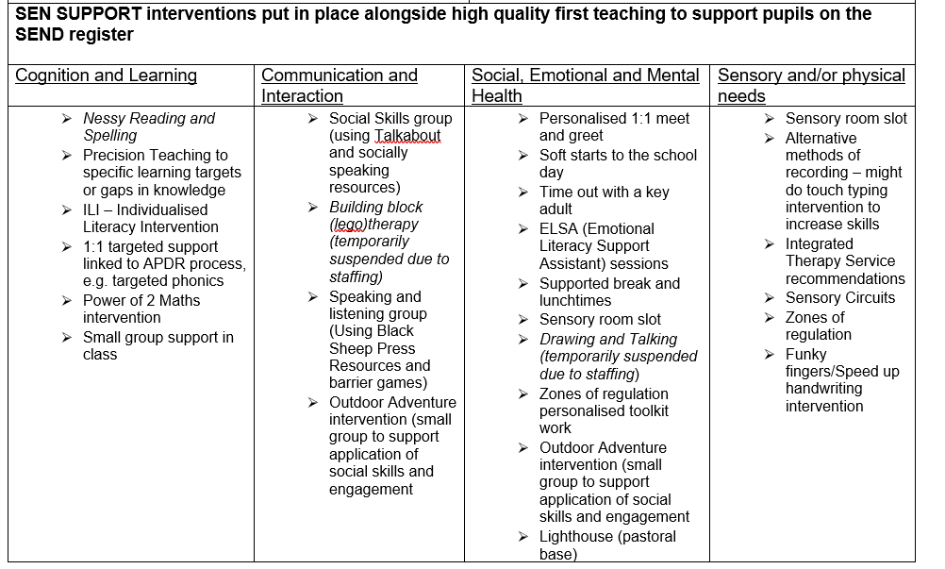    - We also recognise the importance of children’s mental health and well-being alongside that of physical health and learning and achieving successfully  - Every day children complete a zones of regulation emotions chart which helps us to monitor children’s wellbeing and acts as an effective way to quickly identify those that might need some extra support. This support can vary from a comforting chat with a trusted adult to further referrals or signposting to mental health or other support services.  - Our senior mental health lead, Mrs Thomson, liaises with the Somerset Mental Health support service and co-ordinates referrals to the Somerset Mental Health Support Team. This team can offer low intensity CBT support for mild to moderate mental health difficulties for example low mood or anxiety.  - Mrs Robb is our ELSA (Emotional Literacy Support Assistant) who can work with individuals or groups on things such as self-esteem, bereavement and emotional regulation. She is also available in the Lighthouse our pastoral base at break times and half of lunchtime.  - We have developed a sensory room in our school which is used to support children with a wide range of additional needs including those with Autism, sensory processing difficulties and social emotional difficulties. A sensory room is a quiet space dedicated to stimulating, developing and relaxing the senses. Our sensory room allows pupils the freedom and autonomy to explore the environment for themselves, in their own time, using all of their senses. The décor of our sensory room includes low lighting and adjustable lighting projections, fibre optics, mirrors and bubble tubes. It contains a choice of comfortable places to sit, a variety of interesting objects to examine and calming sounds or music. Some groups of children might also follow a sensory circuit programme in the room depending on their needs.  - There are safe spaces and regulation stations around the school and in classrooms which children can use to take a break in order to help them feel calm and ready to learn back in the classroom. There is also a pastoral room called the Lighthouse which is available for those children who might need an alternative space during break or lunchtime. Some children may also need to use the Lighthouse pastoral room during lessons depending on their needs.  - Staff are trained in the use of emotion coaching techniques and PLACE approach to support all pupils in school. We view behaviour as communication and evidence of an unmet need.  - If families needed more help we would meet with them to complete an Early Help Assessment and a Team around the School (TAS) referral in order to identify which services might be able to help. We also signpost parents to online and local counselling services when necessary.  - Our pupil wellbeing champions also work hard to offer peer support at breaks and lunchtime.  
What specialist services and expertise are available at or access by the school and how do you all work together? | As a school we work closely with any external agencies which we feel are important to support your child’s needs within our school, these include;  - The Educational Psychology Service  - Inclusion Line (access to inclusion support)  - Physical Impairment and Medical Support Team  - Hearing Support Team  - Vision support Team  - Speech and Language Therapist  - Occupational Therapist  - Education Engagement Service  There might be times when we also access more specialist services and these might include  - Alternative Provisions, e.g. Equine Assisted Learning, Otterhead Forest School, Boost Academy  - Primary Allocations Panel for outreach support from the Bridge School and/or Polden Bower Special School  We work together by sharing information and having collaborative meetings together with parents to discuss next steps. Outside agencies often form an integral part of a child’s assess, plan, do review process to explore next steps that will work for the child.
How will my child be included in activities outside the classroom including extracurricular clubs and school trips? | Our inclusive curriculum ensures that all children are included in all aspects of school life. This includes trips and extra-curricular clubs. School plans how they will ensure reasonable adjustments are in place in order to meet children’s needs and do so in collaboration and partnership with parents.
How accessible is the school environment?   | - The school site is mainly wheelchair accessible as it is a flat site with a large accessible toilet and an additional accessible toilet and changing bed.  - Our school site uses contrast colours and highlights to support visual impairments  - We work hard to make our school a neuro-affirmative environment  - We believe in full equality and equity for all children and, as such, all children are enabled to participate in all school activities. When planning trips, teachers ensure that the needs of all children are taken into account and where possible the trip will be suitable for all.  - A risk assessment is completed before any off site activities. This ensures that everybody’s Health and Safety is not compromised. Occasionally for health and safety reasons it may be considered unsafe for a child to take part in an activity. If this should occur then an alternative activity will be provided within school which will cover the same curriculum area.  - Appendix 10 of our ‘Supporting Pupils with Medical Needs’ details the guidance we follow when planning trips with pupils who have disabilities. Advice from parents or carers is welcomed and essential on these occasions.
How will the school prepare and support my child to join the school, transfer to a new setting/school/college or for the next stage of education and life? | - The SENCo, Mrs Thomson liaises with the SENCos from other schools as appropriate. She meets with the SENCo of the secondary school in the autumn term to discuss pupils in Year 6 who need additional support and invites them to attend any Annual Reviews and APDR meetings. In the spring there is a further meeting, transition parent coffee morning and the individual needs of the children are discussed and transition plans and additional visits are agreed.  - In addition, we forward any reports written by specialists and any assessments that have been undertaken on the child. We also inform them of current provision, progress, attainment and needs. This also happens for children joining our school.  - For pupils joining us in Year 3, they have the chance of joining in with a ‘buddy scheme’. Year 5 pupils are chosen to support the transition of new pupils from year 2 through extra visits, Q and A sessions and joint activities. This also means that when the pupils join us as Year 3 pupils in September they already have a Year 6 pupil that they know who can help and support them through the transition.  - The SENCo holds school transition tours during the school day and also after school to support those children who may need to visit at a quieter time due to their needs. The SENCo also holds Year 2 parent transition coffee mornings, transition meetings and an activity morning for the parents and their children with SEN ahead of move up day. This gives an opportunity for us to get to know you and vice versa. The children also have an additional time in our school getting to meet and work with our staff.  - Some children already at our school will also have an enhanced transition into their new classes if change is something that is difficult for them. This includes additional visits, social stories and sessions with their new teachers etc ahead of move up day.
If I am not happy with the support my child is getting, what should I do? | If you wish to discuss your child’s special educational needs, or you feel you need to raise a concern please contact the following:  ● Your child’s class teacher  ● The SENCo, Mrs Tamsin Thomson  ● Headteacher, Mr Higgins
Who can I contact for further information? | - The first point of contact would always be your child’s class teacher to share your concerns. Please email or call the school office who will pass your message on to the class teacher who will contact you.  Phone 01278 783558 Email Office@saja.theplt.org.uk  - If your child is on the SEN register you can contact the SENCo, Mrs Thomson  Phone 01278 783558 Email tamsin.thomson@saja.theplt.org.uk  - Somerset SENDIAS is an organisation that provides independent advice and support for families  Phone 01823 355 578 https://somersetsend.org.uk  - For more information on the Local authority offer please visit the link below:  https://choices.somerset.gov.uk/025/local-offer/  - Somerset Parent Carer Forum is an independent group of parents/carers who have joined together to share information, their views and experiences of the children’s/young person’s services (0-25 years) they already use of would like to use in the future.  - Phone: 01278 699397 email:help@somersetparentcarerforum.org  

